**Fixed Income Securities**

**Final Project**

**Group Members:**

Chai, Yanyou

Lei, Beixi

Li, Kexin

Li, Yaxian

Ma, Haijian

**Part I. Pricing Agency-type MBS**

**1. Interest Rate Paths Simulation**

In the first place, CIR model is implemented to generate the interest rate which will be used for calculating discounted cash flow.

To begin with, estimating parameters ALPHA, BETA, VOLATILITY using MATLAB built-in Maximum Likelihood Estimation with last five-year historical interest rate data. As the result, Alpha=1.0082, Beta=0.01502747, Volatility=0.25%.

Next, utilizing R to simulate interest rate matrix of (100,116): 100 paths and each having 116 iterations. All the codes above are attached in the appendix.

**2. Prepayment Model**

**2.1 PSA Model**

First, we use PSA model to calculate the prepayment. Prepayments can be affected by mortgage rates. With a lower mortgage rates, prepayment will increase, and with a higher mortgage rates, prepayment will slow down. PSA model is a popular prepayment model based on empirical experience. From this model, we can calculate CPR and then get SMM. We use VALL function in Bloomberg to get the PSA value of our MBS, which is 140. We assume this value is fixed. This calculation is shown in column H and N.

The sheet *PSA1* displays beginning balance, WAC, WAM, p-t rate, which are fetched from Bloomberg Fannie Mac Pool and used to calculate Mortgage payment, interest, Scheduled principle, SMM, finally prepayment, total cash flow and discount flow will be generated next and model price can be derived.

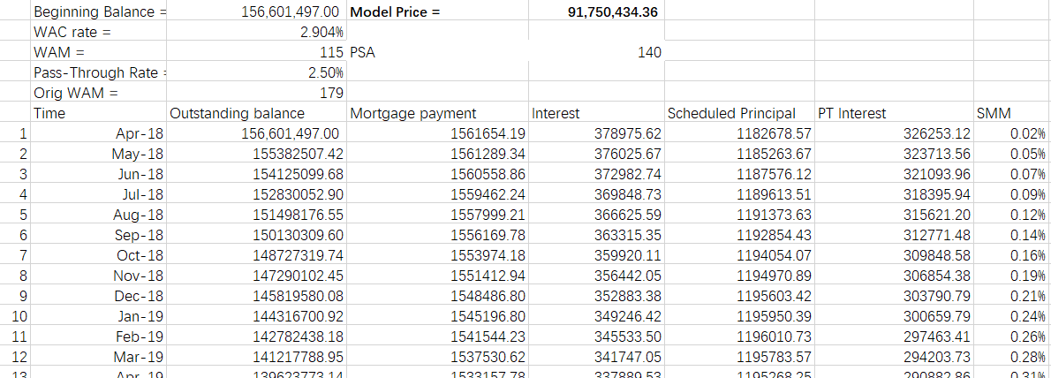

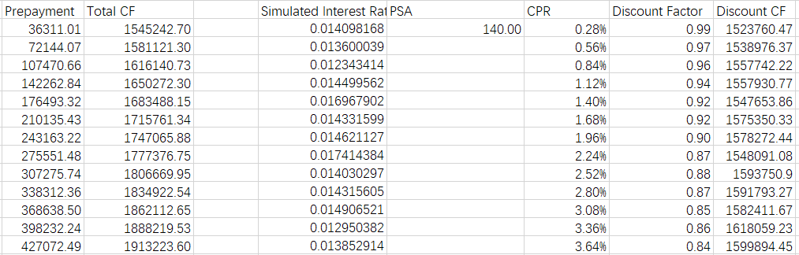*Table: PSA Prepayment and Discount Cash Flow*

Model price = 91,750,434.36, which closes to the market price: $98 million given by Bloomberg in a general way.

**2.2 Bloomberg Model**

As for the Bloomberg model, we use the CFT function to get the cash flow of our MBS. Bloomberg provides built-in functions to simulate prepayment including unscheduled principle, interest with pass-through rate and cashflow. Through the cash flow table generated above, the total cash flow and discounted cash flow could be calculated. Moreover, the model price would be worked out. The sheet *Bloomberg* displays this calculation.

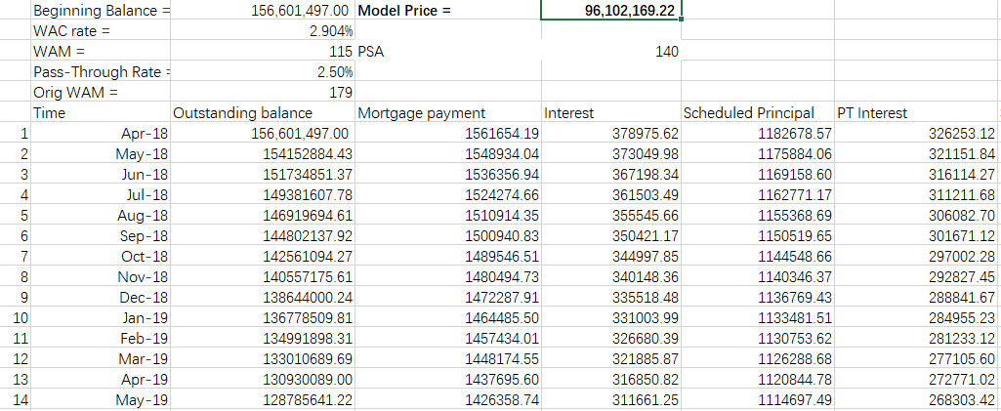

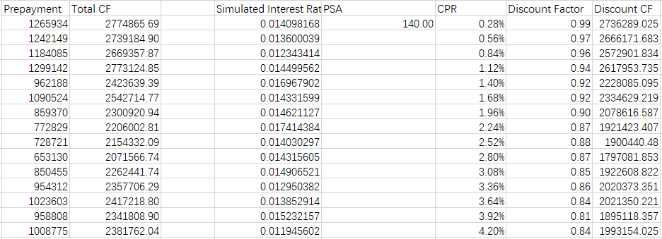

*Table: Bloomberg Prepayment and Discount Cash Flow*

Model price = 96,120,169.2, which approaches to the market price: $98 million given by Bloomberg.

**3. Cash Flow**

The worksheet *interest_rate* stores the simulated rate. Total cash flow equals to PT interest + scheduled principal + prepayment. Then we can calculate the discount cash flow from total cash flow using the 100 interest rate paths. The result is shown in column J.

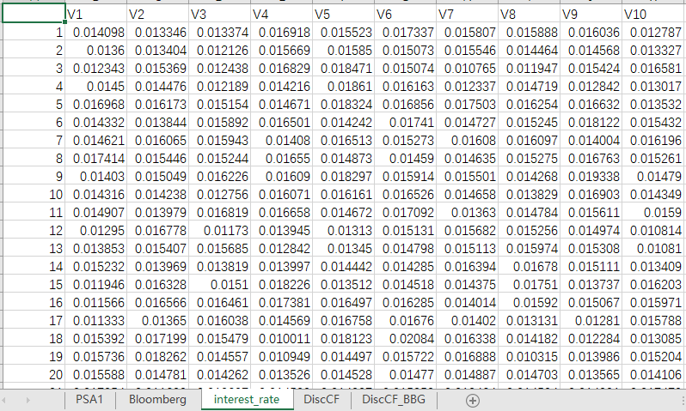

*Table: Simulated data of Interest Rate*

**4. Model Price**

The PSA model price is 91,804,722.24 dollars, and the Bloomberg model price is 96,134,832.74 dollars. Compared with the market price $98.264 million, the model prices are lower but with limited difference.

**Part II. Pricing Private-label-type MBS**

Using the assigned security, now assume that timely payment of scheduled principal and interest on this security is guaranteed by a private financial institution, which is assigned a credit rating of an A by Standard & Poor’s. Compute the value of the security using the approach specified in step 1-4 above but now adjust for credit risk. Comment on your findings.

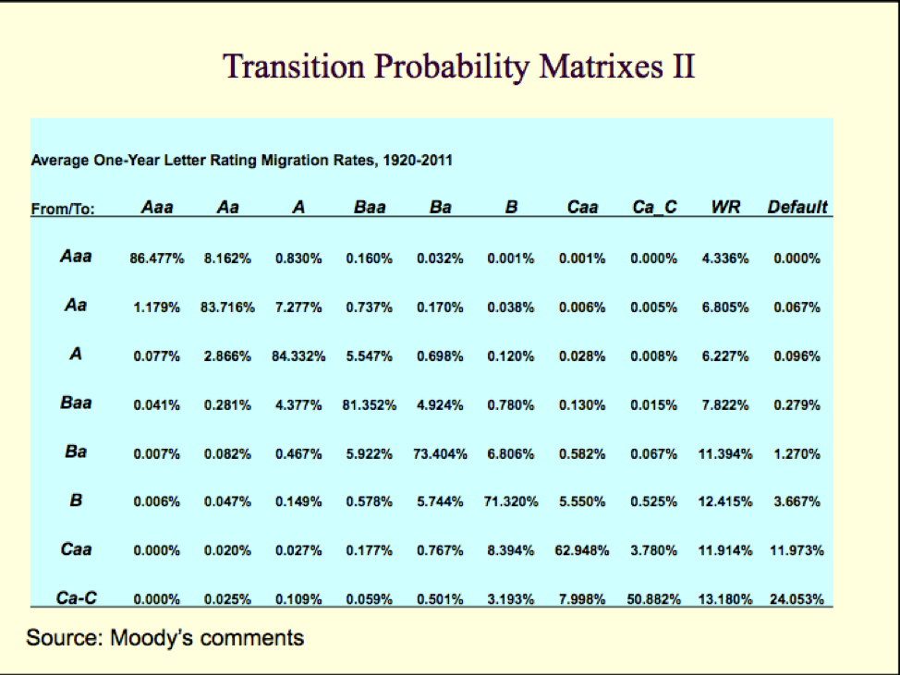

*Table: Default Transition Probability Matrix*

Since we have the transition matrix for 1-year from Moody’s comments, we intended to use the transition probability matrixes with all the credit rating to first compute the expected default probability, where the expected default probabilities are calculated by:

where default vector is the last column containing the default probability for all credit ratings.

Based on the cash flow we calculated by month, and the transition probability matrix are year based, then we need to convert the default probability to monthly based. In addition, our assigned MBS expired at June 2028, there are 10 years remaining until time to maturity, and we only need to calculate the default probability for 10 years, hence 115 months.

Therefore, after getting the default probability for each year until maturity, we can then find the survival probability for each month using the following formula:

where i is the month in the year.

After that, considering the survival probability, we need to find the PV for asset. Using projected CF, we can price MBS using the following formula:

where M is the month at the maturity.

Therefore, the final results from 2 different models are as below:

|  |  |  |
| --- | --- | --- |
| Model | Model Price in Part 1 | Model Price in Part 2 |
| PSA | 91,804,722.24 | 91,145,631.84 |
| Bloomberg | 96,134,832.74 | 95,612,852.20 |

Therefore, from the table we could see the result from both parts. Because we consider the default probabilities in part 2, the model price is a little bit lower than in the part 1. Because the market price for the assigned MBS is nearly 98.476 quoted (i.e. 98476000), the reason may be due to our underlying asset keeps a credit rating of A for the whole lifetime, the default probability of this level asset is nearly close to 0. Thus, the asset could survival easily for the whole lifetime. The default risk associated this a MBS is pretty low, and the it does not have too much on our underlying asset.

Finally, the model price in part 2 is a litter bit lower than in part 1, this may due to the reason that we consider the default probability, while in part 1 we use PSA.

**Appendix**

*Likelihood function in MATLAB*

function llfunc = likelihood(alpha,beta,Volatility,dt, Y)

llfunc = 0;

%Y_avg = mean(Y);

for i = 2:length(Y)

mu = Y(i-1)*exp(-alpha*dt)+(1-exp(-alpha*dt))*beta;

sigma = Volatility*sqrt((1-exp(-2*alpha*dt))/(2*alpha));

llfunc = llfunc+log(normpdf(Y(i),mu,sigma));

end

end

*Maximum Likelihood Estimation in MATLAB*

[raw,~,~] = xlsread('interest rate.xls');

Price = raw(1:end,3)/100;

Return = price2ret(Price);

%theta0 = [0.012, 0.025];

%objfunc = @(theta)-likelihood(theta(1),theta(2), Price);

%[thetahat,fval,exitflag,output,fval1,fval2] = fminunc(objfunc,theta0);

theta0 = [0.01,0.004, 0.02];

objfunc = @(theta)-likelihood(theta(1),theta(2),theta(3),1/252, Price);

A = [];

b = [];

Aeq = [];

Ceq = [];

lb = [0 0 0];

ub = [1000 1000 10000];

[thetahat,fval,~,~,~,~,fval2] = fmincon(objfunc,theta0, A, b, Aeq, Ceq, lb, ub);

*Interest Rate Simulation in R*

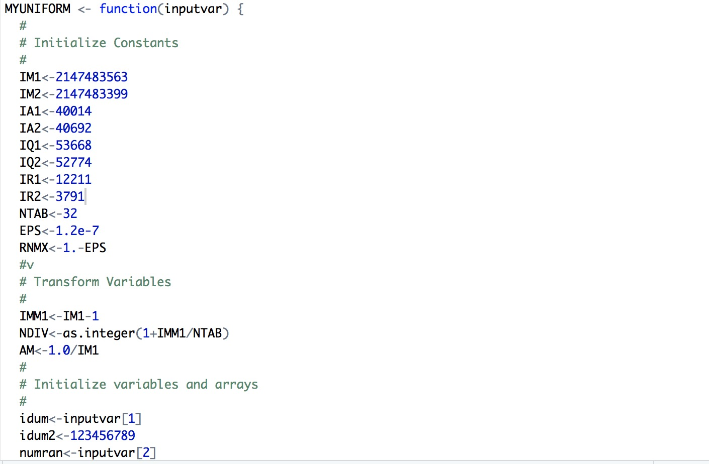

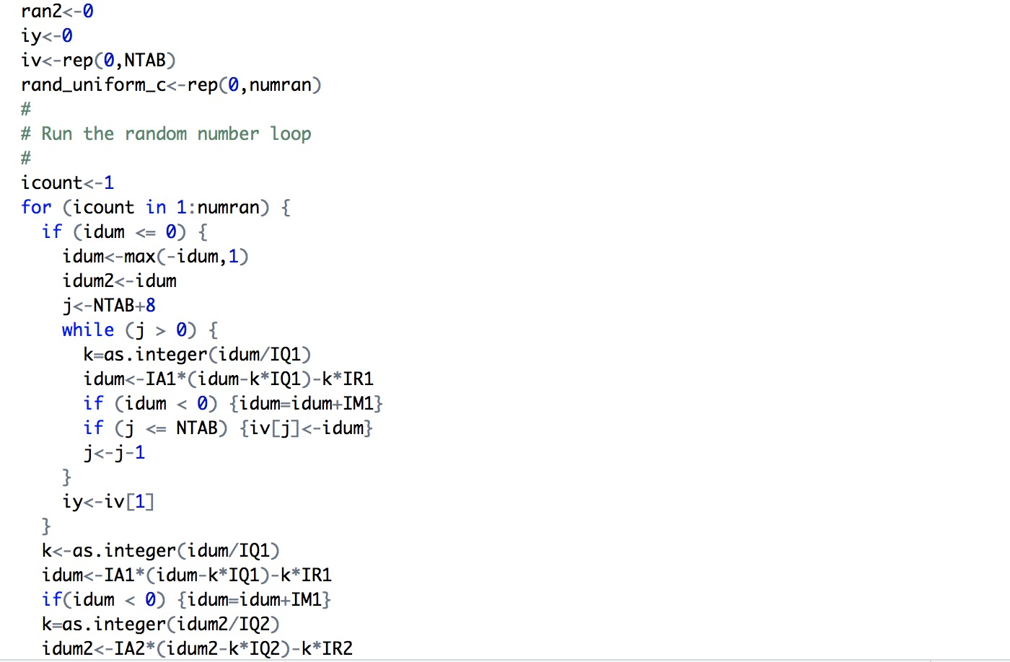

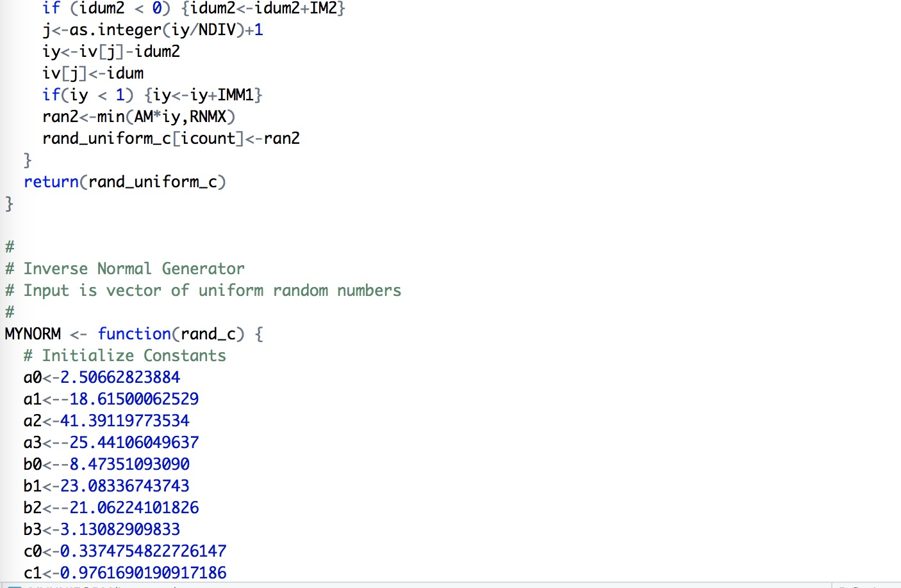

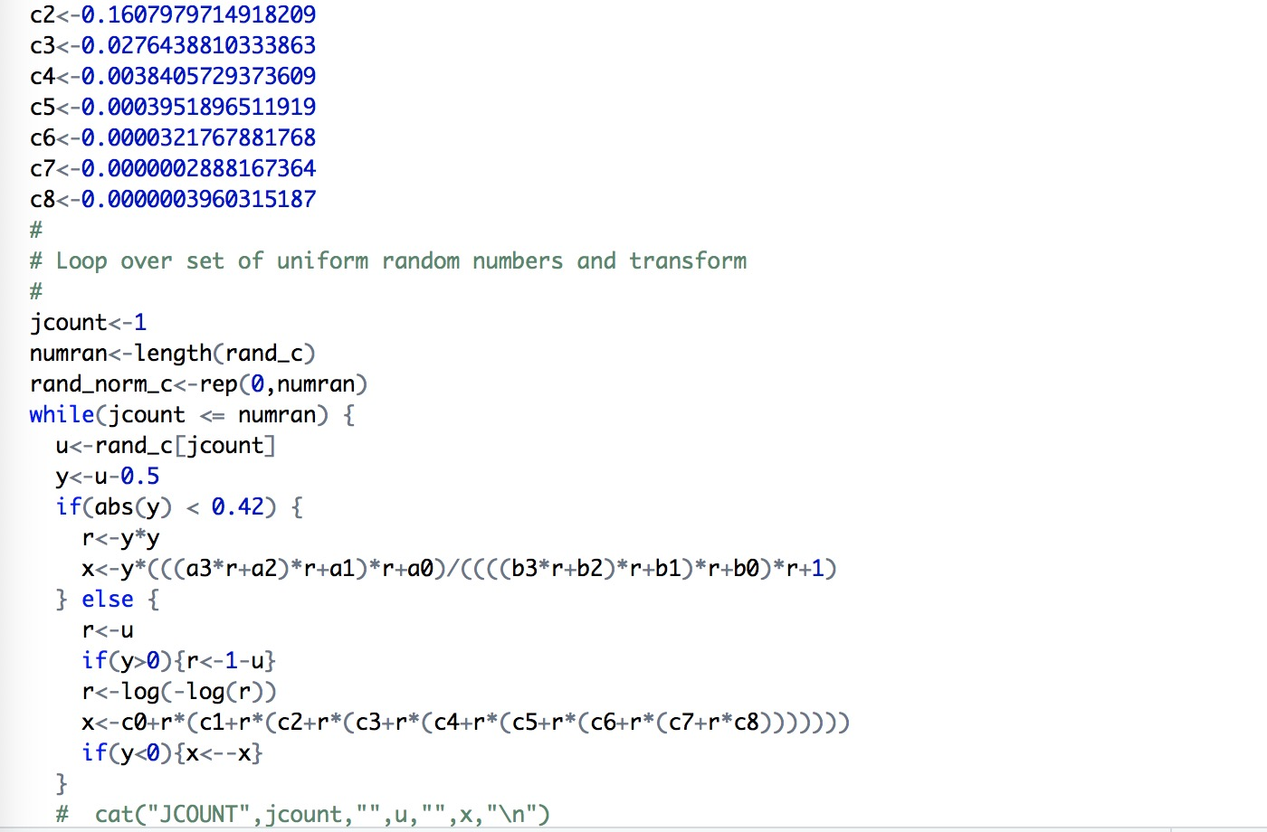

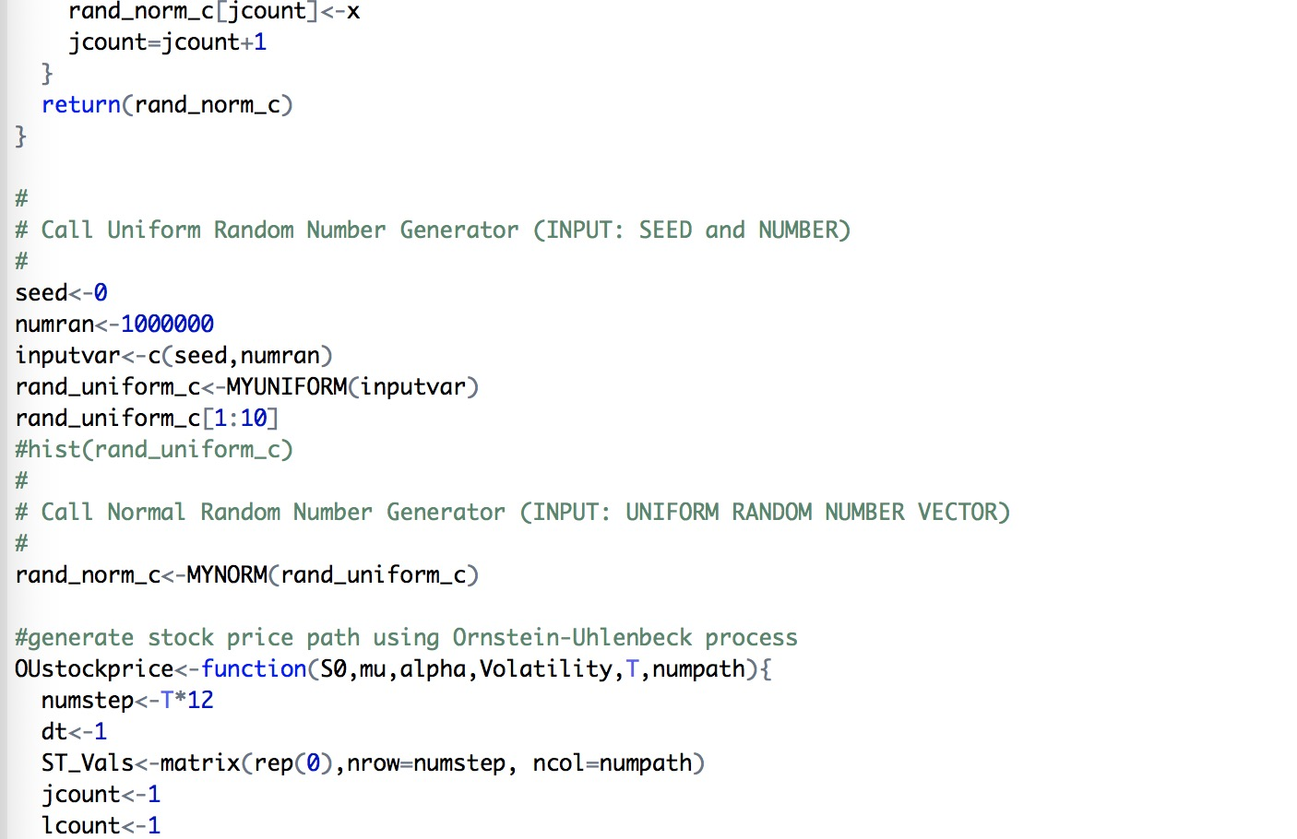

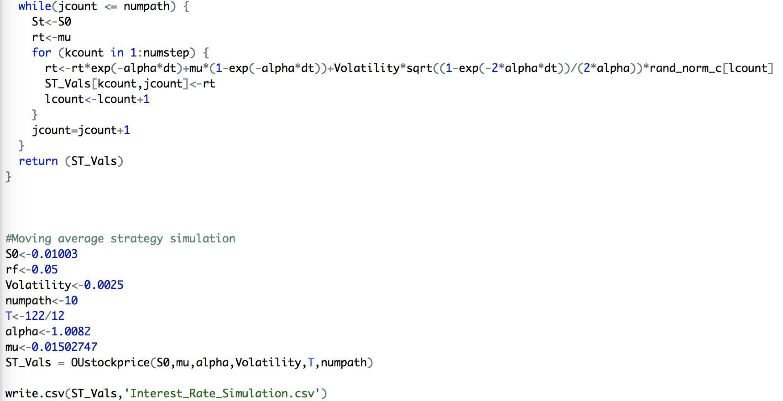

*PSA Discount Cash Flow: 100 Paths * 116 Iterations*

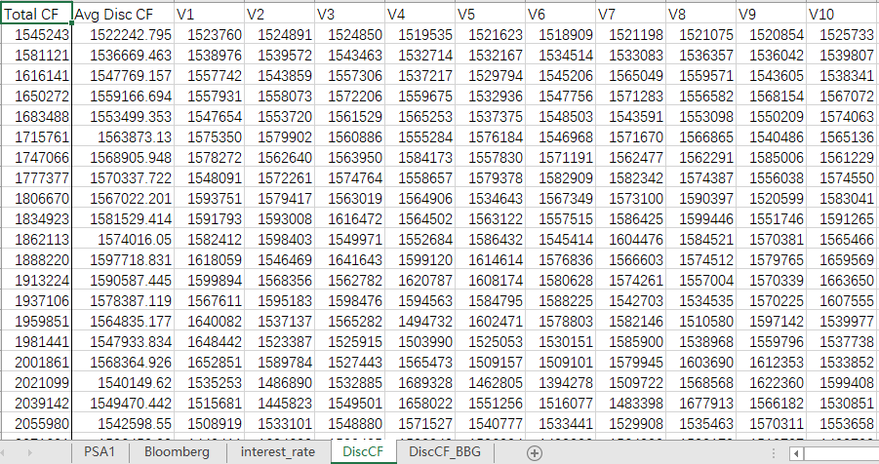

*Bloomberg Discount Cash Flow: 100 Paths * 116 Iterations*

